**Thermal Management of a Drone Pod System**

|  |  |
| --- | --- |
| Charlie Nitschelm | Joseph Williams |

|  |  |  |
| --- | --- | --- |
|  | Thomas Collins |  |

Abstract

|  |  |
| --- | --- |
| The department of defense has contracted us to complete an analysis of a thermal management system for a drone pod system. This task shall be completed in three sections. First is two analysis consisting of temperature vs entropy and pressure vs enthalpy. The second section is coefficient of performance (COP) vs temperature (T) for three selected refrigerants. Investigation will also include the thermal, environmental safety, and cost considerations as to determine the best refrigerant for the drone pod. The last analysis will be focused towards the COP again with factoring in the difference from the outside temperature to the working fluid temperature and its respective actual performance on the field. |  |

Pod Shell material and thickness

To establish the shell material and thickness of the pod we first had to analyze the thermal properties of different metals and composites at the environments they will be operating. At drone takeoff and apogee, the pod mist be able to maintain an inside temperature of 20 °C while experiencing outside environment temperatures of -20 °C and 50 °Cat apogee and takeoff, respectively. Our chosen materials for further analysis were carbon fiber, fiberglass, aluminum, and magnesium (AZ61/AZ31). Carbon fiber and magnesium both had relatively low densities of 1700 kg/m3 and 1800kg/m3respectively, when compared to the higher densities of fiberglass at 2550kg/m3 and aluminum, the material with the highest density at 2700kg/m3 [1]. Aluminum also had the highest thermal conductivity of all the tested materials with a conductivity of 147W/mK at -20 °C and 155W/mK at 50 °C. Fiberglass had the lowest thermal conductivities at -20 °C and 50 °C being 0.0325W/mK and 0.038W/mK while the other composite, carbon fiber, had slightly higher thermal conductivities at 0.5W/mK and 0.8W/mK[2]. Both magnesium alloys had thermal conductivities ranging from 60 to 85W/mK[2]. Using the densities, thermal conductivities, and factoring in the dimensions for our 2-meter-long, 0.4 meters high, and 0.38-meter-wide pod we were able to determine an optimal thickness of 2mm (Figure 1), looping an array of thicknesses through our equation below.

$Req=\frac{1}{h1A1}+\frac{ln⁡(\frac{r2}{r1})}{2πk}+\frac{1}{h2A2}$ (1)

that maximized the resistance to minimize the heat transfer across the pod.  With both the graph created comparing heat transfer and material thickness and the graph comparing shell mass and material thickness we concluded that fiberglass is the best suited material for the pod with low heat transfer. Fiberglass provided the third lightest pod frame at 13.79kg but had a substantially lower heat transfer rate of 7500 J/s and 7,300J/s at takeoff and apogee, respectively, when compared to the other materials at our found ideal material thickness. The values for heat transfer with respect to its pod thickness can be seen in figures 2 and 3 for takeoff and apogee, respectively. This provided the fiberglass pods worst case scenario which will take place at takeoff because of the slightly higher heat transfer to the pod. Aluminum was selected to be the second pod shell material to analyze to cross reference our in-depth analysis of fiberglass to conclude that our preferred material is correct. Aluminum would yield a heat transfer of 14,500 J/s at takeoff to the shell, which is nearly double the rate for our fiberglass predictions.

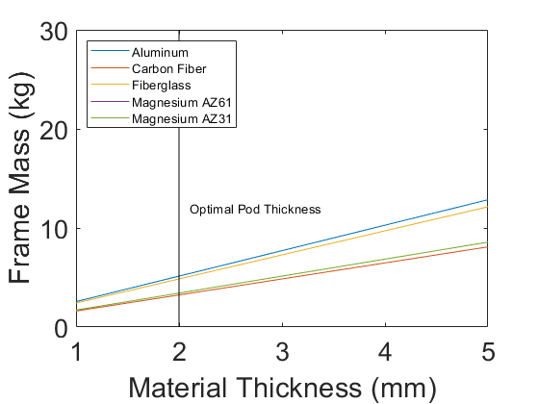

Figure 1 - Frame Mass vs. Material Thickness for various pod materials

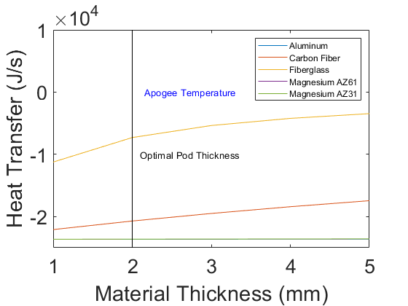

Figure 2 - Heat Transfer vs. Material Thickness at Apogee

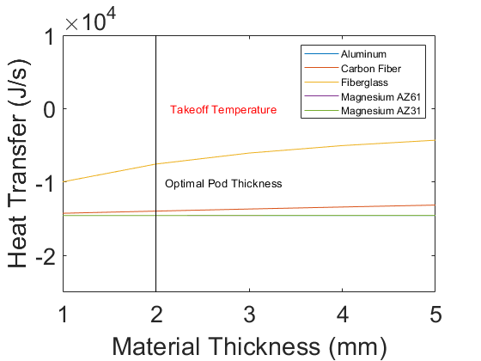

Figure 3 - Heat Transfer vs. Material Thickness at Takeoff

**REFRIDGERANT SELECTION**

Once the pod materials and optimal thickness were determined, the next parameter to calculate is the choice of the refrigerant for the thermal management system. From an array of four widely used refrigerants we can narrow them down to a top choice involving it COP, compressor power and required mass flow rate[3].

(2)

$\dot{m}=\frac{Cooling Capacity}{∆h_{evaporator}}$ (3)

A performance analysis can then happen to determine our most effective refrigerant for takeoff, the worst-case scenario for our pod designs. This performance analysis will also include considerations regarding to the refrigerants environmental impact and safety handling.

MATLAB and CoolProps was utilized to numerically calculate the COP

$COP= \frac{h_{1}-h_{4}}{h_{2}-h_{1}}$ (4)

of the refrigeration cycle at takeoff as seen in Figure 4. By interpreting this plot, we conclude that the COP at the extreme scenarios (specifically takeoff) are where deviations between each refrigerant’s performance appear. A sweep of 20 different refrigerants COP’s were calculated to narrow down the top four refrigerants with the highest COP. The COP’s with respect to the thermal management system of the drone pod at takeoff for fiberglass and aluminum are acetone, ammonia, R290, and R410 with a COP of 6.50, 6.08, 5.41 and 4.87 respectively [3][4].

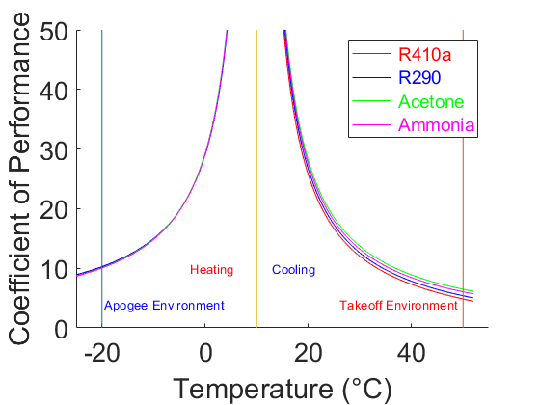

Figure 4 - Coefficient of Performance vs. Temperature for Refrigerants

The compressor power vs. temperature graph is crucial in determining the compressor to be integrated into the system and verifying the performance of the system with respect to the COP conclusions. Compressor power, COP and mass flow rate are all directly proportional to each other. These trends are exaggerated as your environment temperature reaches your working fluid temperature, where the amount of work required from the refrigeration system approaches zero, causing COP to approach to infinity which can be seen in Figure 5 and 6 for the fiberglass and aluminum pod design, respectively. R410a, R290, acetone, and ammonia require the most to least compressor power at takeoff which requires the cycle to act as a refrigeration system to cool the pod to its desired temperature in both scenarios.

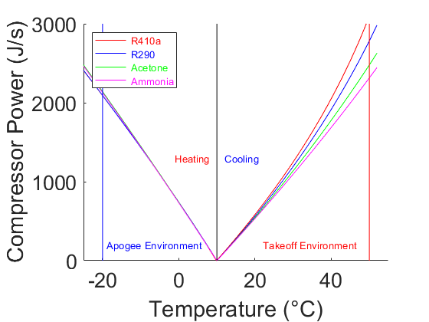

Figure 5 - Compressor Power vs. Temperature for Refrigerants in Aluminum Pod

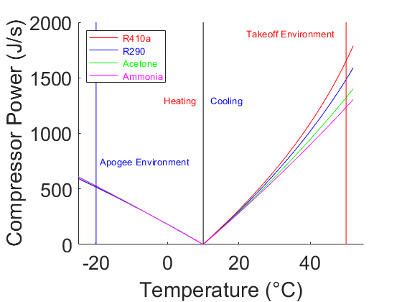

Figure 6 - Compressor Power vs. Temperature for Refrigerants in Fiberglass Pod

The mass flow rates of the selected refrigerants in the fiberglass and aluminum designs are graphically interpreted in Figures 7 and 8. These data show mass flow rate values plotted vs. outside temperature ranging between its takeoff and apogee environment temperatures. The graph trends such that the mass flow rate increases as the environment temperature moves further away from the desired pod temperature. Very similar trends are seen from the mass flow rate vs. outside temperatures compared to the compressor power figures above.

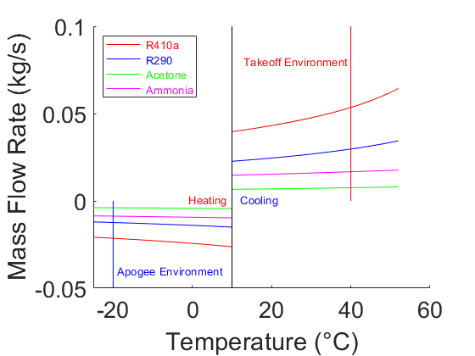

Figure 7 - Mass Flow Rate vs. Temperature for Fiberglass Pod

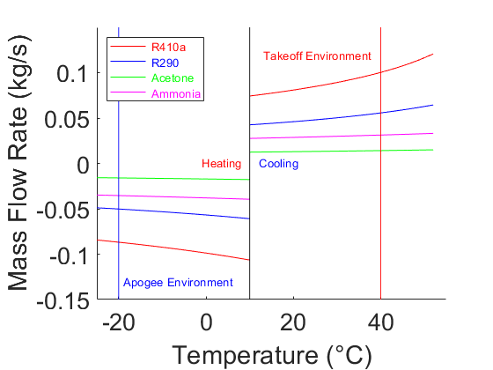

Figure 8 - Mass Flow Rate vs. Temperature for Aluminum Pod

The last portion in our performance analysis is the environmental impact, safety handling, and overall cost of the refrigerant. Ammonia is extremely harmful to humans and the environment with a lethal dose being 300ppm over a 30min timespan [5]. Acetone, although the most efficient and least mass flow rate, is too dangerous regarding its environmental impact and safety.  R290 has little to zero impact on the environment and is non-toxic to people when handling [12]. It is also a desirable refrigerant in terms of price, with it costing $7.00 per kilogram. R410a is not harmful to people in acute doses and has a market cost of $13.2 per kilogram [6][8][10].

With the considerations of COP, compressor power, mass flow rate, environmental impact, safety handling and cost, R290 is clearly the most desired refrigerant for the system. Ammonia and acetone are too dangerous to any operators that would need to handle it, leading to our 3rd highest COP refrigerant at takeoff to be used for further analysis on the refrigerant system on both our pod designs.

**HEAT EXCHANGER DESIGN**

Following our shell design and refrigerant selection we had to design two worst case scenario heat exchangers that would fit within our specifications. Taking convection coefficients and overall mass into consideration, we decided that PVC and copper piping would provide the widest range of results due to their difference in physical properties, from which we could determine the most ideal piping material for our two heat exchangers.

To establish the inner and outer radii of our pipes we first decided on the length for one long pipe as our heat exchanger, knowing that we could divide the pipe into many equal lengths to create the same amount of heat exchange based on its exposed surface area. We discovered the required outside radius of 1 large pipe and broke that surface area into several pipes of 5cm in diameter. This was completed by using an array of outside radii to loop through an equation

$\dot{Q}=\frac{L*∆T}{\frac{1}{2π}(\frac{1}{h1r1}+\frac{\ln\left(\frac{r2}{r1}\right)}{K}+\frac{1}{h2r2})}$ (5)

to determine total resistance using our determined change of

temperature, convection coefficients of air and R290, thermal conductivity of pipe material, and inner radius relating to our desired pipe thickness of 0.8mm (1/32 inch) until it resulted in a rate of heat transfer equivalent to the heat transfer we had previously calculated for the pod design material. This relationship can be seen below in Figures 9 and 10 for fiberglass and aluminum, respectively.

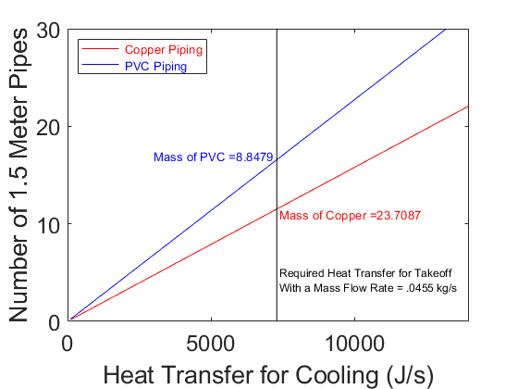

Figure 9 - Number of Pipes vs. Heat Transfer for Cooling in the Fiberglass Pod

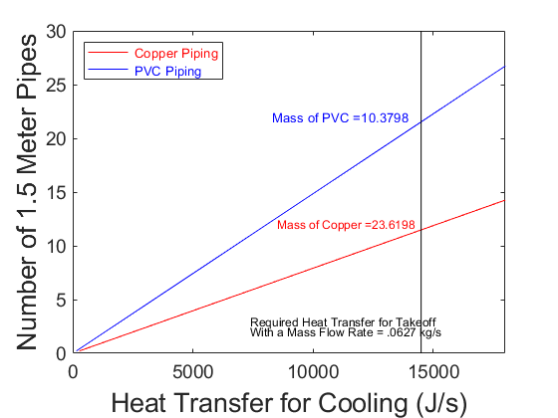

Figure 10 - Number of Pipes vs. Heat Transfer for Cooling in the Aluminum Pod

We calculated that we needed 12, 1.5-meter pipes to operate the cycle given the thermal conductivity of the copper pipes and the heating/cooling of our system at the extreme temperature environments. Knowing the required heat transfer we determined the mass flow rate required to be 0.0433Kg/s for fiberglass, as seen in Figure 9 and 0.0627Kg/s for aluminum as seen in Figure 10. A negative mass flow rate direction correlates on whether the cycle is cooling or heating, resulting in a change in flow direction, as shown in both figures. The radius, and the density of R290 could assist in finding the average velocity of the flow speeds in the tubes, which resulted in 5.1 m/s and 7.9 m/s for fiberglass and aluminum pod designs, respectively.

After the radii, length, and number of the pipes had been calculated, we could then analyze the volume and the mass of the heat exchanger. To find the volume we used the cross-sectional area multiplied by the length and then multiplied that by the number of required pipes resulting in volumes of 0.0075 $kg/m^{3}$ and 0.0026 $kg/m^{3}$ for PVC and copper pipes respectively. Using the volumes and the known densities of PVC and copper we could calculate the final masses of the heat exchangers to be 23.6kg for copper piping and 10.37kg for PVC piping. From the risk of PVC corrosion over time with the presence of R290, we settled for using copper tubing, which yielded larger mass, but safer operation risk over time. The drone pod needs to be able to function for 6,000 hours before any maintenance, who eliminated the risk of using PVC as its corrosion could fail the system over that time.

**IDEAL CYCLE ANALYSIS**

Ideal Cycle Analysis is essential in the optimization and design of our system. By comparison between the ideal and the actual cycle we can determine which properties need improvement and which meet our design requirements. In this section will show and discuss the temperature vs entropy and pressure vs enthalpy of our aluminum and fiber glass pod designs.

Figures 11 and 12 observe the temperature vs entropy graphs for our fiberglass and aluminum pod designs with COP and total heat transfer for our takeoff and apogee conditions. The ideal cycle, which will be analyzed later, deviates from the actual refrigeration cycles due to pressure drops related to fluid flow. In an ideal cycle there will be no pressure drops within the piping of a system, and transitions between vapor and liquid will happen as dictated by the ideal gas law.

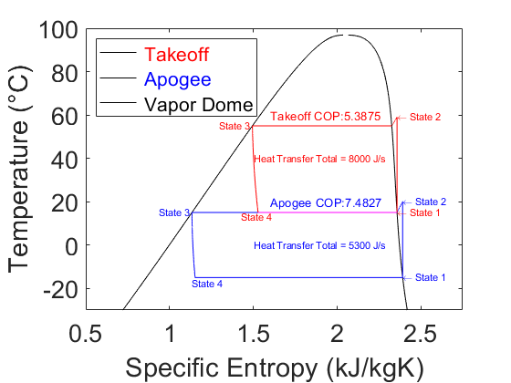

Figure 11 - Temperature vs. Specific Entropy for Fiberglass Pod

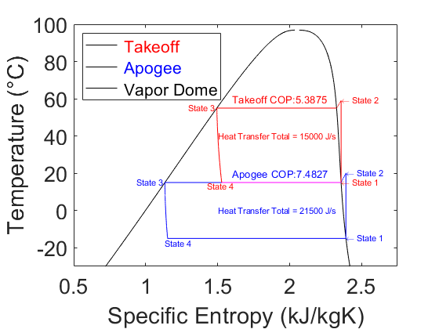

Figure 12 - Temperature vs. Specific Entropy for Aluminum Pod

Figures 13 and 14 observe the pressure vs. specific enthalpy graphs for our fiberglass and aluminum pod designs. In the ideal cycle there is no irreversibility or heat transfer in the compression process, where these are typically dependent on the temperature of the refrigerant and environment. This lack of irreversibility results in the isentropic line from state 1 - 2. As you can see in the figures below, our fiberglass design yields lower heat transfers required at the extreme environments, allowing for less of a load on our heat exchangers, therefore decreasing overall weight. These graphs also confirm that the takeoff environment is the worst-case scenario for both pod designs as the COP for the takeoff environment temperature is lower than at apogee.

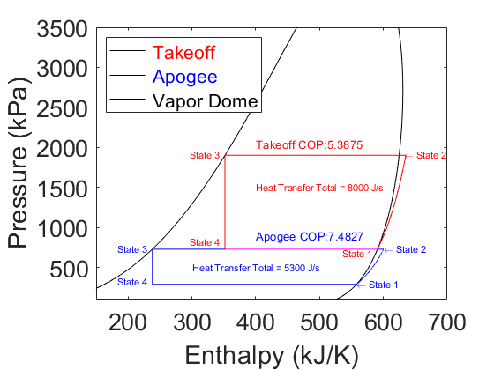

Figure 13 - Pressure vs. Enthalpy for Fiberglass Pod

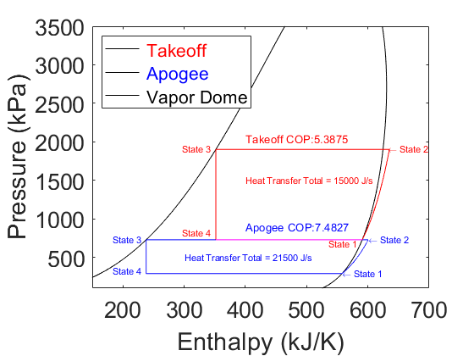

Figure 14 - Pressure vs. Enthalpy for Aluminum Pod

**COMPRESSOR SPECIFICATION AND ACTUAL CYCLE**

After careful deliberation we decided that the Copeland Scroll™ would be the most appropriate compressor for our pod. The Scroll provides 20kW of heating capacity with a small footprint of 250/246/450 mm at a weight of only 20kg, perfect for fitting within the pod. The variable speeds allow for a more constant pressure at a lower rate of power consumption. The Scroll operates with a COP of 3.2 and an efficiency of 0.8 and is specifically designed to use R290, our chosen refrigerant [7].

Using the efficiency of our compressor and accounting for the pressure drops in the heat exchanger, we created a new nonideal, variable drive, refrigeration cycle with the effects of our calculated head loss from equations

$R_{eD}=\frac{4\dot{m}}{πr^{2}μ_{R290}}$ (6)

$F=\frac{64}{R_{eD}}$ (7)

$V_{avg}= \frac{\dot{m}}{ρ_{R290}πr^{2}}$ (8)

$HeadLoss=\left(F\frac{L}{d}*\frac{V_{avg}^{2}}{2g}\right)n_{pipes}$ (9)

in the pipes at each state in the P-h and T-s diagrams. As seen in Figures 15 and 16, which illustrate our fiberglass pod design, provide a pressure drop in the compressor which causes a slight increase in entropy and results in a lower temperature at state 1, while at state 2 both the entropy and temperature are increased. The pressure drop through the condenser also results in a decrease in temperature, enthalpy, and entropy from state 2 to 3. State 4 is the only state that remains unchanged from the ideal cycle.

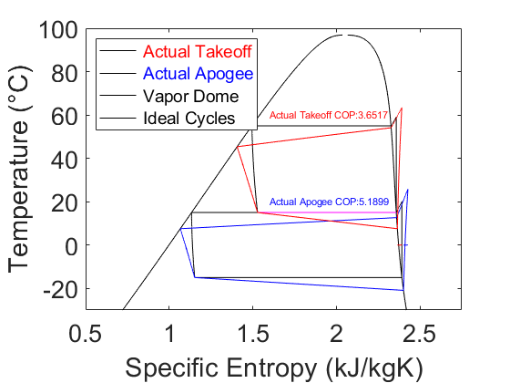

Figure 15 - Non-Ideal Temperature vs. Specific Entropy of the Fiberglass Pod

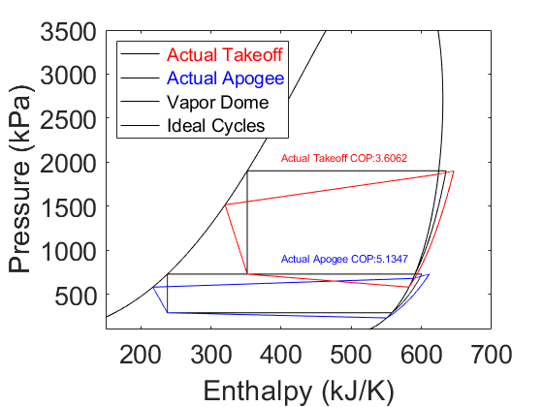

Figure 16 - Non-Ideal Pressure vs. Enthalpy of the Fiberglass Pod

Figures 17 and 18 illustrate the same relationships but for our aluminum pod design. The COP for our aluminum pod differs from the fiberglass actual COP, determining that our fiberglass pod will have the more efficient design, ideal and actual.

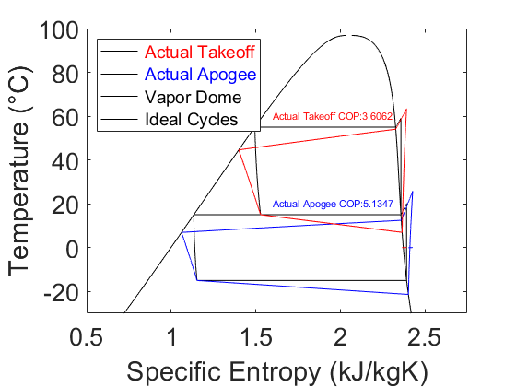

Figure 17 - Non-Ideal Temperature vs. Specific Entropy of the Aluminum Pod



Figure 18 - Non-Ideal Pressure vs. Enthalpy of the Aluminum Pod

**FINAL DESIGN**

The Department of Defense contracted us to design a thermal management system for a drone pod with specific dimensions and performance capabilities. We were required to account for total mass of less than 125lb or 56.699kg. Through our analysis we designed two pods, one fiberglass and one aluminum, where both structures include R290 as the refrigerant working fluid.

The fiber glass structure we designed had a total mass of 37kg. This mass is a summation of three parts, the shell mass, working fluid mass, and mass of the refrigerator and heat exchanger. Our shell total mass was 13.8 kg, a working fluid total mass of 0.20 kg, and the cycles and copper piping total mass is 23.7 kg. Our refrigerant choice and heat exchanger specification to produce a total heat transfer capability of 8kw at takeoff.

The Aluminum structure we designed had a total mass of 38.5 kg. Our shell total mass was 14.6 kg, working fluid total mass was 0.20459kg, and the cycles and copper piping total mass is 23.7kg. Through our refrigerant and heat exchanger analysis we were able to design a system that could produce a total heat transfer capability of 15kw at takeoff.

 With both designed presented, each of the requirements from the Department of Defense have been fulfilled. Our recommendation is for the D.o.D. to manufacture their pod as the fiberglass one specified throughout the report. This decision was reached due to accounting for the efficiency, power, and stress on the system.

.

Acknowledgments

Ivo.

References

1. “Densities of Metals - Chempendix.” Google Sites, sites.google.com/site/chempendix/densities-of-pure-metals.
2. “Thermal Conductivity of Metals.” Thermal Conductivity of Metals, www.engineeringtoolbox.com/thermal-conductivity-metals-d_858.html.
3. Refrigerants - Physical Properties, www.engineeringtoolbox.com/refrigerants-d_902.html.
4. “R410A.” R410a - CoolProp 6.1.0 Documentation, [www.coolprop.org/fluid_properties/fluids/R410A.html#fluid-r410a](http://www.coolprop.org/fluid_properties/fluids/R410A.html#fluid-r410a)
5. “The National Institute for Occupational Safety and Health (NIOSH).” Centers for Disease Control and Prevention, Centers for Disease Control and Prevention, 4 Dec. 2014, www.cdc.gov/niosh/idlh/7664417.html.
6. “R290 (CARE 40) Propane.” Linde Gas, www.linde-gas.com/en/products_and_supply/refrigerants/natural_refrigerants/r290_propane/index.html.
7. “R-410A.” Wikipedia, Wikimedia Foundation, 18 Sept. 2018, en.wikipedia.org/wiki/R-410A.
8. B. D. Bivens, et al. “R-410A – Application Experience.” R-410A – Why Is It Such an Interesting

Refrigerant Fluid, www.eurocooling.com/public_html/articler410a.htm.

1. “Author Templates.” ASME.org, [www.asme.org/shop/proceedings/conference-publications/author-templates](http://www.asme.org/shop/proceedings/conference-publications/author-templates).
2. “Risks and Benefits.” Acetone,badacetone.weebly.com/risks-and-benefits.html.
3. Refrigerants, National. “R123 Safety Data Sheet.” SDS, www.refrigerants.com/pdf/SDS%20R123.pdf.
4. “Acetone | Price | per Kg | USD.” PharmaCompass.com, www.pharmacompass.com/price/acetone.